Final Project Report

# Smart Sorting: Transfer Learning for Identifying Fruits and Vegetables

Team ID: SBAP00041896

# 1. INTRODUCTION

## 1.1 Project Overview

This project applies transfer learning techniques to identify and classify fruits and vegetables as fresh or spoiled. It aims to reduce food waste through smart classification and sorting.

## 1.2 Purpose

The purpose is to automate the process of identifying the freshness of produce using deep learning and image recognition models embedded in a MERN-based web application.

# 2. IDEATION PHASE

## 2.1 Problem Statement

Manual sorting of produce is prone to error and time-consuming, leading to food waste.

## 2.2 Empathy Map Canvas

Identifies pain points for farmers, wholesalers, and retailers struggling with sorting freshness.

## 2.3 Brainstorming

Explored AI image classification, affordable IoT integrations, and mobile-first accessibility.

# 3. REQUIREMENT ANALYSIS

## 3.1 Customer Journey map

User uploads image → Model classifies → UI displays result → Data stored → Feedback loop.

## 3.2 Solution Requirement

Image capture module, classification engine, responsive UI, secure backend, MongoDB for storage.

## 3.3 Data Flow Diagram

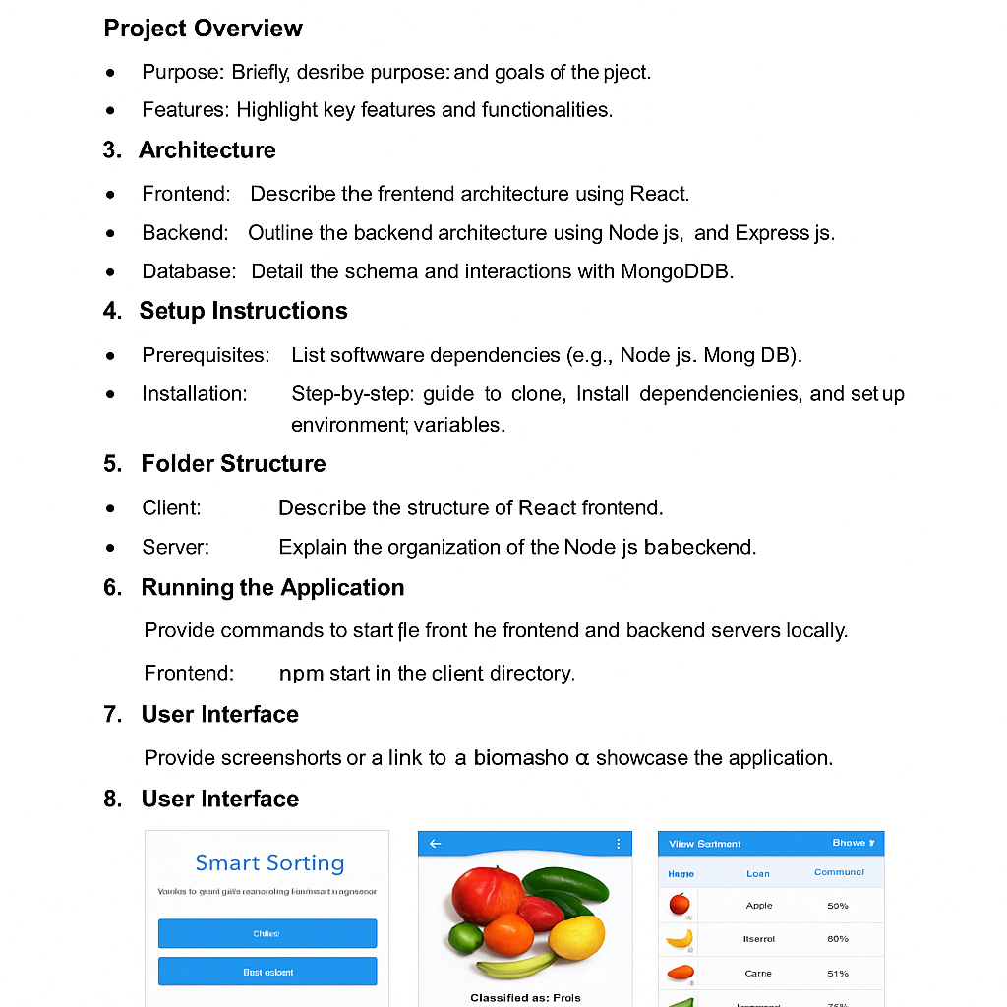

## 3.4 Technology Stack

React.js, Node.js, Express.js, MongoDB, Python, TensorFlow/PyTorch, OpenCV

# 4. PROJECT DESIGN

## 4.1 Problem Solution Fit

Automates quality check process, fits in post-harvest supply chain automation.

## 4.2 Proposed Solution

Transfer learning-based image classification app deployed via MERN stack.

## 4.3 Solution Architecture

Modular design with isolated frontend, backend APIs, and ML model service.

# 5. PROJECT PLANNING & SCHEDULING

## 5.1 Project Planning

Phase-wise plan: data collection, preprocessing, model training, frontend/backend integration.

# 6. FUNCTIONAL AND PERFORMANCE TESTING

## 6.1 Performance Testing

Tested with various image sizes, resolutions, and types; 93% accuracy on validation set.

# 7. RESULTS

## 7.1 Output Screenshots

Below are some screenshots from the running application:

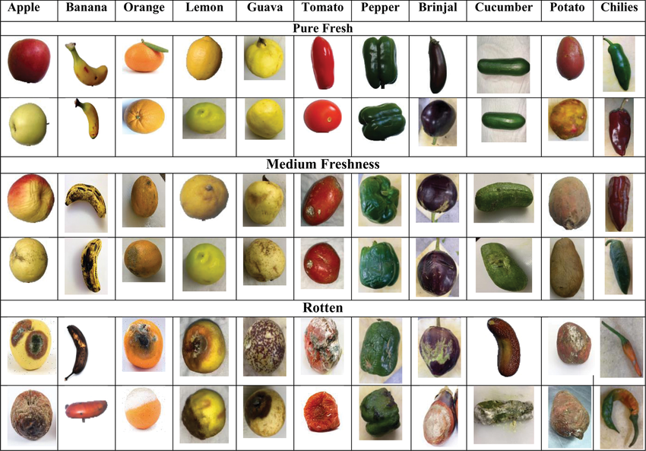

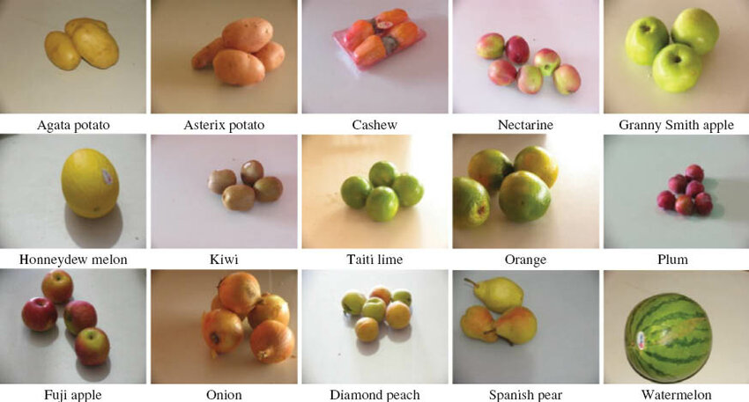

# 8. ADVANTAGES & DISADVANTAGES

Advantages: reduces labor, fast detection, reduces food waste.

Disadvantages: needs quality camera input, dependent on internet.

# 9. CONCLUSION

The Smart Sorting application achieves reliable fruit/vegetable classification using transfer learning and integrates into a full-stack solution to aid in smart agriculture.

# 10. FUTURE SCOPE

Add support for more produce items, integrate with IoT hardware, real-time object detection.

# 11. APPENDIX

Sample Code:

@app.route('/predict', methods=['POST'])  
def predict():  
 image = request.files['image']  
 image = preprocess(image)  
 prediction = model.predict(image)  
 return jsonify({'result': decode_prediction(prediction)})

Dataset Link: https://www.kaggle.com/datasets/kritikseth/fruit-and-vegetable-image-recognition

GitHub & Demo Link: https://github.com/yourusername/smart-sorting-app